OOP ASSIGNMENT 1:

1. A

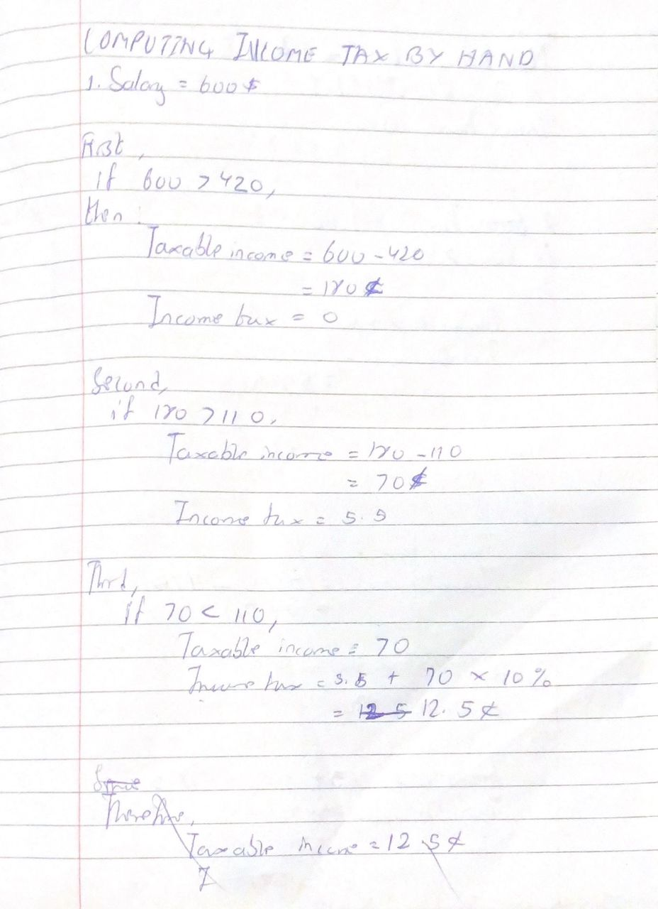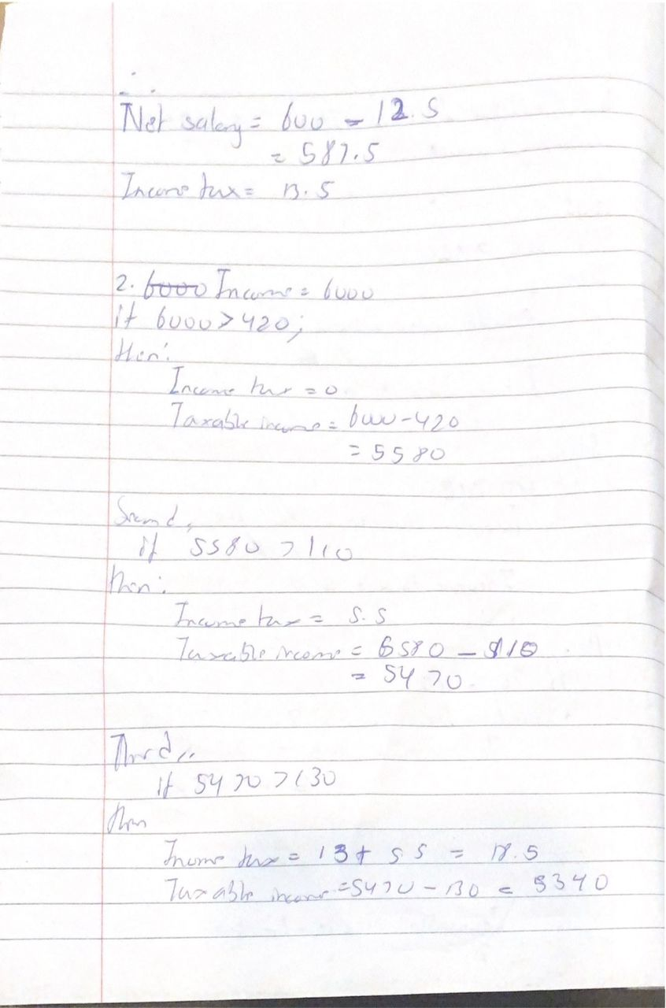

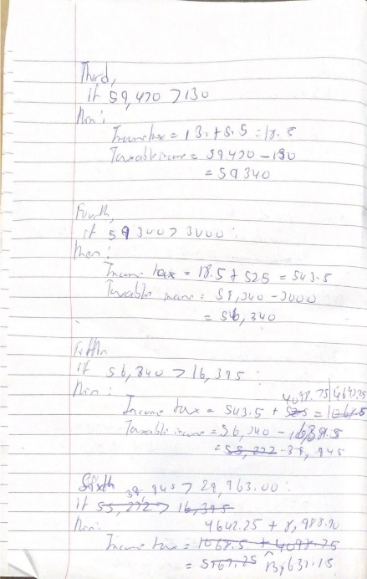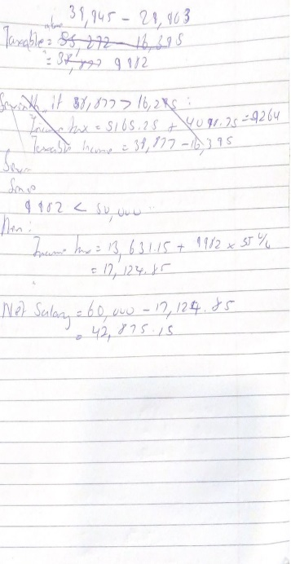

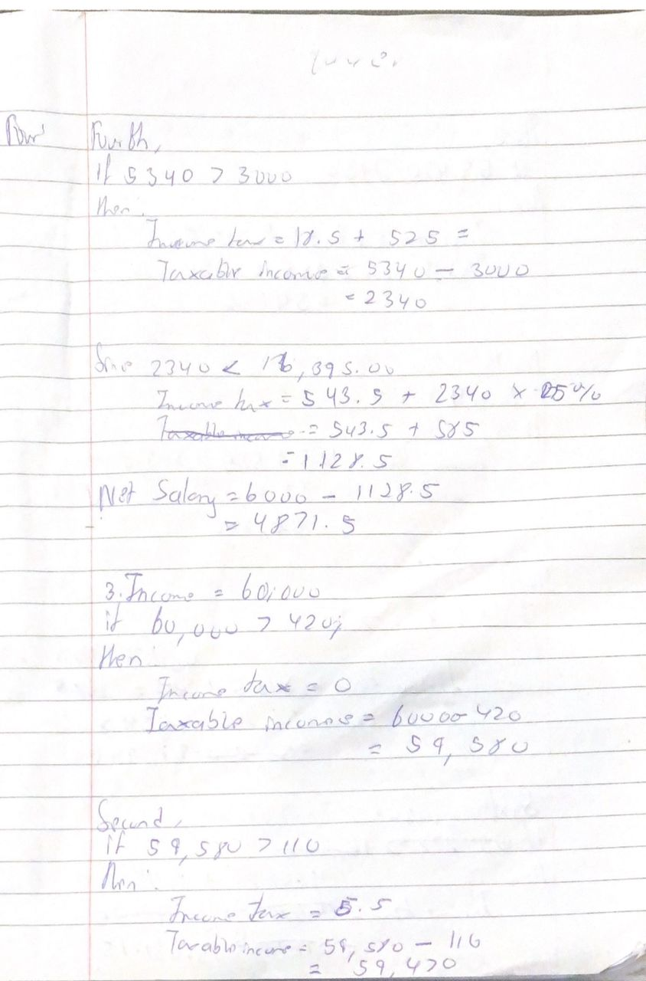

B. For my test cases, I used the values 600, 6000 and 6000 since I had already solved them by hand and would have an accurate solution to compare the output of my program with.

**OUTPUT**

i.

"Enter Gross Monthly Salary: 600

Income Tax: 585.7"

Reasoning:

This output was mainly to check the first conditions of my program, primarily to make sure that the intervals set for taxation were working correctly.

Ii.

"Enter Gross Monthly Salary: 6000

Net Income: 4867.0"

Reasoning:

Based on the algorithm structured for the tax calculation functionality of the program, the higher the income, the more it is taxed. This output ensured that my program implemented this logic based on the rates implemented in the source code.

Iii

"Enter Gross Monthly Salary: 60000

Net Income: 42868.85"

Reasoning:

This test case was used to make sure that the program performs all tax deductions to produce better or more accurate results.

**N.B:** This was done in both Java and Python, respectively.